**Ruteo OSPF de área única**

|  |
| --- |
| **ESPECIFICACIÓN** |
| **Dirección IP de la subred: 175.3.0.0/25** |
| **Máscara de subred: 255.255.255.128** |
| **Cantidad de host utilizables por la subred: 126** |
| **Primera dirección del host: 173.3.0.1** |
| **Última dirección de host: 173.3.0.126** |

|  |
| --- |
| **ESPECIFICACIÓN** |
| **Dirección IP de la subred: 184.3.0.0/26** |
| **Máscara de subred: 255.255.255.192** |
| **Cantidad de host utilizables por la subred: 62** |
| **Primera dirección del host: 184.3.0.1** |
| **Última dirección de host: 184.3.0.62** |

|  |
| --- |
| **ESPECIFICACIÓN** |
| **Dirección IP de la subred: 129.3.0.0/25** |
| **Máscara de subred: 255.255.255.128** |
| **Cantidad de host utilizables por la subred: 126** |
| **Primera dirección del host: 129.3.0.1** |
| **Última dirección de host: 129.3.0.126** |

|  |
| --- |
| **ESPECIFICACIÓN** |
| **Dirección IP de la subred: 117.3.0.0/25** |
| **Máscara de subred: 255.255.254.0** |
| **Cantidad de host utilizables por la subred: 510** |
| **Primera dirección del host: 117.3.0.1** |
| **Última dirección de host: 117.3.1.254** |

|  |  |  |  |  |
| --- | --- | --- | --- | --- |
| **Dispositivo** | **Interfaz** | **Dirección IP** | **Máscara de Subred** | **Gateway por defecto** |
| R1 | Fa0/0 | 175.3.0.126 | 255.255.255.128 | –––– |
| Se0/0/0 | 1.2.3.1 | 255.255.255.252 | –––– |
| Se0/0/1 | 4.5.6.1 | 255.255.255.252 | –––– |
| R2 | Fa0/0 | 184.3.0.62 | 255.255.255.192 | –––– |
| Se0/0/0 | 4.5.6.2 | 255.255.255.252 | –––– |
| Se0/0/1 | 1.4.2.1 | 255.255.255.252 | –––– |
| Se0/1/0 | 1.2.4.1 | 255.255.255.252 | –––– |
| R3 | Fa0/0 | 129.3.0.126 | 255.255.255.128 | –––– |
| Se0/0/0 | 1.2.3.2 | 255.255.255.252 | –––– |
| Se0/0/1 | 1.4.2.2 | 255.255.255.252 | –––– |
| Se0/1/0 | 1.3.6.1 | 255.255.255.252 | –––– |
| R4 | Fa0/0 | 117.3.1.254 | 255.255.254.0 | –––– |
| Se0/0/0 | 1.2.4.2 | 255.255.255.252 | –––– |
| Se0/0/1 | 1.3.6.2 | 255.255.255.252 | –––– |
| PC0 | NIC | 175.3.0.1 | 255.255.255.128 | 175.3.0.126 |
| PC1 | NIC | 175.3.0.2 | 255.255.255.128 | 175.3.0.126 |
| PC2 | NIC | 184.3.0.1 | 255.255.255.192 | 184.3.0.62 |
| PC3 | NIC | 184.3.0.2 | 255.255.255.192 | 184.3.0.62 |
| PC4 | NIC | 129.3.0.1 | 255.255.255.128 | 129.3.0.126 |
| PC5 | NIC | 129.3.0.1 | 255.255.255.128 | 129.3.0.126 |
| PC6 | NIC | 117.3.0.1 | 255.255.254.0 | 117.3.1.254 |
| PC7 | NIC | 117.3.0.2 | 255.255.254.0 | 117.3.1.254 |

Tabla de ruteo para cada uno de los ruteadores, con el siguiente formato:

|  |  |  |  |  |
| --- | --- | --- | --- | --- |
| **Origen** | **Máscara** | **Dirección de red** | **Dirección de Próximo Salto** | **Interfaz de salida** |
| R1 | 255.255.255.252 | 1.2.3.0 | –––– | Se0/0/0 |
| 1.2.4.0 | 4.5.6.2 | Se0/0/1 |
| 1.3.6.0 | 1.2.3.2 | Se0/0/0 |
| 1.4.2.0 | 1.2.3.2 | Se0/0/0 |
| 4.5.6.2 | Se0/0/1 |
| 255.255.255.252 | 4.5.6.0 | –––– | Se0/0/1 |
| 255.255.255.255 | 10.0.0.0 | –––– | Loopback1 |
| 11.0.0.0 | –––– | Loopback2 |
| 255.255.254.0 | 117.3.0.0 | 1.2.3.2 | Se0/0/0 |
| 4.5.6.2 | Se0/0/1 |
| 255.255.255.128 | 129.3.0.0 | 1.2.3.2 | Se0/0/0 |
| 255.255.255.128 | 175.3.0.0 | –––– | Fa0/0 |
| 255.255.255.192 | 184.3.0.0 | 4.5.6.2 | Se0/0/1 |

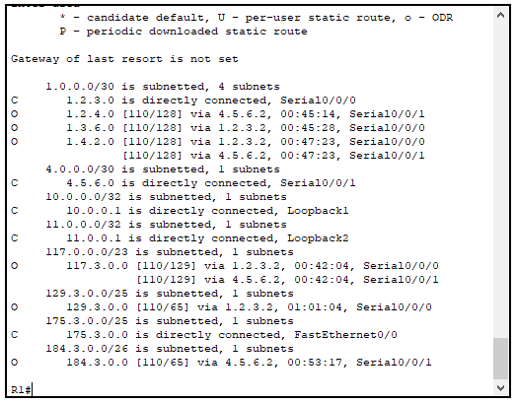

|  |  |  |  |  |
| --- | --- | --- | --- | --- |
| **Origen** | **Máscara** | **Dirección de red** | **Dirección de Próximo Salto** | **Interfaz de salida** |
| R2 | 255.255.255.252 | 1.2.3.0 | 4.5.6.1 | Se0/0/0 |
| 1.4.2.2 | Se0/0/1 |
| 1.2.4.0 | –––– | Se0/1/0 |
| 1.3.6.0 | 1.4.2.2 | Se0/0/1 |
| 1.2.4.2 | Se0/1/0 |
| 1.4.2.0 | –––– | Se0/0/1 |
| 255.255.255.252 | 4.5.6.0 | –––– | Se0/0/0 |
| 255.255.255.255 | 11.0.0.2 | –––– | Loopback1 |
| 255.255.255.255 | 12.0.0.1 | –––– | Loopback2 |
| 255.255.255.252 | 13.0.0.0 | –––– | Loopback3 |
| 255.255.254.0 | 117.3.0.0 | 1.2.4.2 | Se0/1/0 |
| 255.255.255.128 | 129.3.0.0 | 1.4.2.2 | Se0/0/1 |
| 255.255.255.128 | 175.3.0.0 | 4.5.6.1 | Se0/0/0 |
| 255.255.255.192 | 184.3.0.0 | –––– | Fa0/0 |

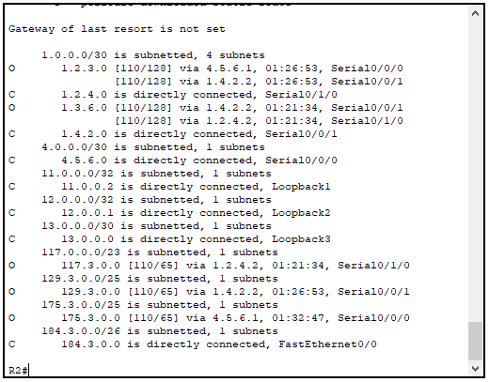

|  |  |  |  |  |
| --- | --- | --- | --- | --- |
| **Origen** | **Máscara** | **Dirección de red** | **Dirección de Próximo Salto** | **Interfaz de salida** |
| R3 | 255.255.255.252 | 1.2.3.0 | –––– | Se0/0/0 |
| 1.2.4.0 | 1.4.2.1 | Se0/0/1 |
| 1.3.6.2 | Se0/1/0 |
| 1.3.6.0 | –––– | Se0/1/0 |
| 1.4.2.0 | –––– | Se0/0/1 |
| 255.255.255.252 | 4.5.6.0 | 1.2.3.1 | Se0/0/0 |
| 1.4.2.1 | Se0/0/1 |
| 255.255.255.255 | 10.0.0.2 | –––– | Loopback1 |
| 255.255.255.255 | 12.0.0.2 | –––– | Loopback2 |
| 255.255.255.255 | 14.0.0.1 | –––– | Loopback3 |
| 255.255.254.0 | 117.3.0.0 | 1.3.6.2 | Se0/1/0 |
| 255.255.255.128 | 129.3.0.0 | –––– | Fa0/0 |
| 255.255.255.128 | 175.3.0.0 | 1.2.3.1 | Se0/0/0 |
| 255.255.255.192 | 184.3.0.0 | 1.4.2.1 | Se0/0/1 |

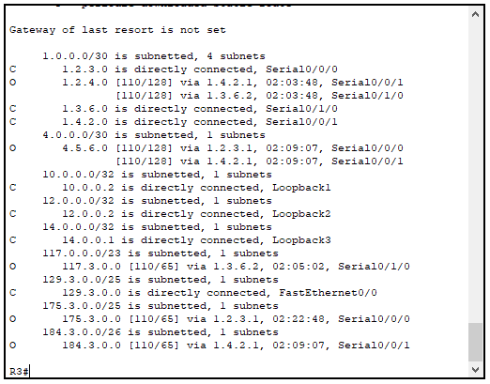

|  |  |  |  |  |
| --- | --- | --- | --- | --- |
| **Origen** | **Máscara** | **Dirección de red** | **Dirección de Próximo Salto** | **Interfaz de salida** |
| R4 | 255.255.255.252 | 1.2.3.0 | 1.3.6.1 | Se0/0/1 |
| 1.2.4.0 | –––– | Se0/0/0 |
| 1.3.6.0 | –––– | Se0/0/1 |
| 1.4.2.0 | 1.3.6.1 | Se0/0/1 |
| 1.2.4.1 | Se0/0/0 |
| 255.255.255.252 | 4.5.6.0 | 1.2.4.1 | Se0/0/0 |
| 255.255.255.255 | 13.0.0.2 | –––– | Loopback1 |
| 255.255.255.255 | 14.0.0.2 | –––– | Loopback2 |
| 255.255.254.0 | 117.3.0.0 | –––– | Fa0/0 |
| 255.255.255.128 | 129.3.0.0 | 1.3.6.1 | Se0/0/1 |
| 255.255.255.128 | 175.3.0.0 | 1.3.6.1 | Se0/0/1 |
| 1.2.4.1 | Se0/0/0 |
| 255.255.255.192 | 184.3.0.0 | 1.2.4.1 | Se0/0/0 |

